# “Introduction”

INTRODUCTION TO PROJECT

INTRODUCTION:-

Generally Computers are used in areas where human are deficient. We are deficient in things like fast view or visit many pages about new collection of jewellery, searching for specific information communicating at higher speed & so on.

Currently, our client is visiting all pages manually. They are maintaining all pages and keeping all information about pages.

The “Saubhagya Jewellers” owner wants a general software package to be made that helps far easy and efficient processing of . After careful study of the manual website we came to know that processing some things is very tedious and time consuming task. Client study wants to speed of processing pages. They want to find pages of their product , product details without wasting their precious time some pages such as product details, their rates, their product images and other information are required, which takes lot of time since it is prepared manually.

Therefore need for computerisation is must, which provide efficiently and effective solution for the present manual system . This project is the solution for the difficulties that are faced by them with manual website. We have put ASP.NET to work for wide range of applications that comes day after day. We have designed this project using the ASP.NET as front-end and ORACLE as back-end.

Our project gives facility for high accuracy as processing page and visiting pages. Fast visiting of pages is much easier.

#### INTRODUCTION TO EXISTING SYSTEM

I] MANUAL SYSTEM:-

In manual system for maintaining customer details they must have to take more efforts. After every transection they need to maintain records of every transaction which is consuming.

II] NEED OF CUMPUTERIZED SYSTEM:-

Reduce processing time as compare to manual system. As compare to manual system reduces time required for maintaining records of every transection occurred in system.

The two main benefit’s provided by the computerize system that are as follow:

1. To Reduce work load.
2. To Reduce paper work.

Jewellers management system

#### INTRODUCTION TO ORGANIZATION PROFILE :-

Name :-

**Jewellers Management System** For **“Saubhagya jewellers”.**

Address :-

AT/post:- Patan, Pin Code :- 415206 Tal:-patan,

Dist:-Satara,

Purpose :-

For providing trusted services to customers.

Service :-

Provides various service details of Jewellery Shop.

Future Aim :-

We will increase the extra antique designs by providing them As a trusted facilities.

Jewellers management system

#### PROPOSED SYSTEM

###### Objectives of Proposed System :-

* 1. To provide good services.
  2. To save time.
  3. To give fast and accurate Result.
  4. To increase efficiency and good will.
  5. To secure private data.
  6. Easy for decision making.
  7. To reduce the paper work.

Jewellers management system

Questionnaires

Q1. Who is the owner of this business?

* Mr. Nitin sharma.

Q2. When you start your business?

* In 2015.

Q3. Which type of jewellery provided by your shop?

* Gold, Silver, Platinum, Stone, etc.

Q4. How many employee’s works for your shop?

* Four employee works in the shop.

Q5. Which is the special jewellery type in your shop?

* Rani Har(Diamond)& Shrimannt Har(Gold). Q6. Is the order system included in your shop?
* Yes,We are accept any order of customer requairement. Q7. You are add the Services-Tax(GST) in the Bill’s ?
* Yes, We are Add GST in the Bill’s.

Jewellers management system

##### SOFTWARE REQUIREMENT SPECIFICATION

**# FEASIBILITY STUDY:**

**Technical Feasibility:-**

* Software requirement (Recommended)

|  |  |  |
| --- | --- | --- |
| Operating System | :- | Windows 10 |
| Programming Language | :- | C# .NET |
| Database | :- | Oracle 10g |
| Report | :- | Crystal Report |

* Hardware requirement(Recommended)

|  |  |  |
| --- | --- | --- |
| Processor | :- | P4 or Higher |
| Monitor | :- | 1024*768 pixel |
| Hard Disk | :- | 500 MB |
| RAM | :- | 2 GB |
| Printer | :- | Cannon Ink jet. |

1. **Operating Feasibility:-**

Operating feasibility ends at checking if the system will be help the user to work in more efficient & accurate manner through all routine operation. The system is made to be comprehensive in nature, using a full menu driven system & appropriate user informative message. On the contrary, the workload on the user will be lessened to the great extent, as a system is aimed at taking care of the complex procedure & automatic calculation. Thus the system is operational feasibility.

1. **Economical Feasibility:-**

While considering economic feasibility, it is checked in point like performance, information & outputs for the system. Economic of the system look at the financial aspect of the project. It determines whether the system is economical feasible, in other words it determines whether the investment that goes into the implementation of the system is recoverable.

# “System Analysis”



PROVIDE SALARY

GIVE ORDER AS REQUIREMENT

PROVIDE SERVICES

PROVIDE QUATATION AS PER

ENQUIRY FOR THE ORNAMENT

GET ALL DETAILS REPORT

PROVIDE VARIOUS FACILITIES

CONTROL ON THE SYSTEM

Jewellers management system

**DFD:**

**0th**

**Level DFD**

Customer

Employee

0.0

Jewelry

Management

System

Owner

Supplier

BALASAHEB DESAI COLLEGE,PATAN. **Page 10**

Jewellers management system

### 1st Level DFD



Sales & Purchase

System for Saubhagya Jwellers

1.0

2.0

Owner

maintain system, control all the system & maintain proper report.

Supplier

supply the products & give receipt get payment

to system.

Supplier

information Order information



3.0

Employee daily works for system follow instruction & get salary.

Employee

information



4.0

Customer view ornament & give order to system & get services pay bill, get receipt.

Customer

information

##### **ERD :-** For Sales & Purchase System for jewelry Management System.

Addr

Shop name

ID

Contact

Name

Type

Category

Name

Mobile no

Add

ID

Name

Gender

ID

Product

Owner

Customer

Purchase

Getsalary Dailywork

Quatation

From

Give order

Get service

Employee

Dealer

ID

Name

Contact

Salary

ID

Gender

Addr

Name

Email id

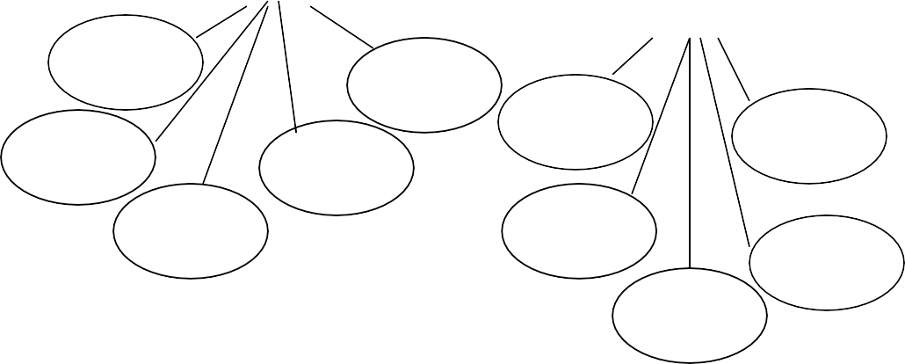

Contact

Contact

# “System Design”

### Database Design

#1.Employee Information Table

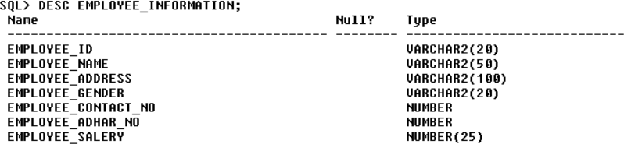

**#2.Customer Information Table**

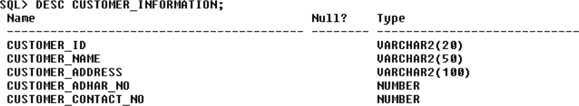

**#3.Dealer Information Table**

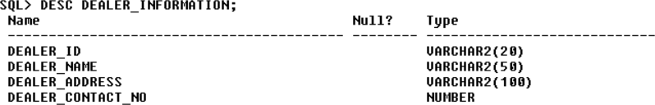

Jewellers management system

#4.Product Information Table

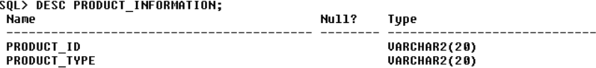

**#6.Product Type Information Table**

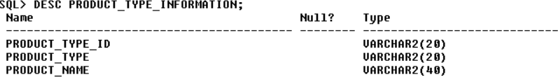

**#7.Product Type Details Table**

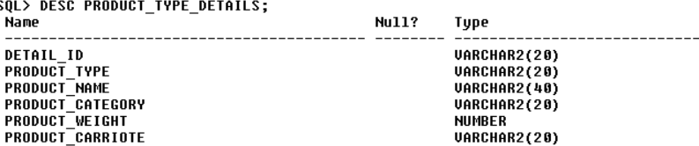

Jewellers management system

#8.Purchase Order Table

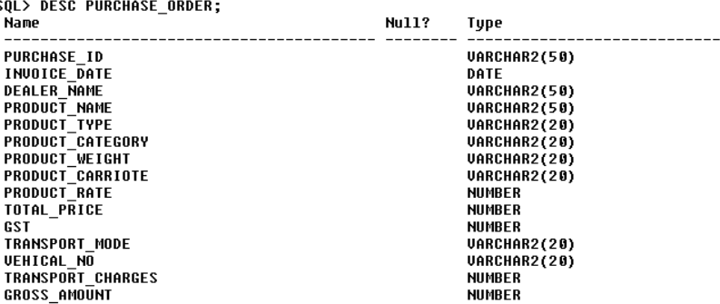

**#9.Bill Information Table**

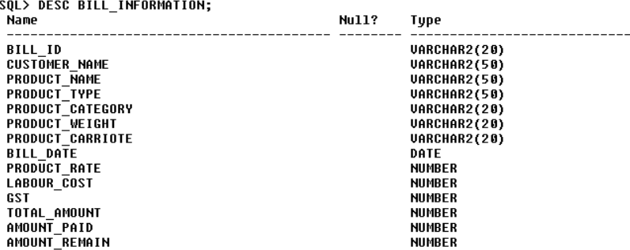

**#10.Credit Information Table**

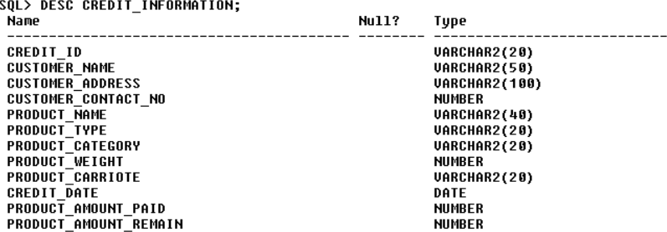

“Forms Design”

**Login Form**

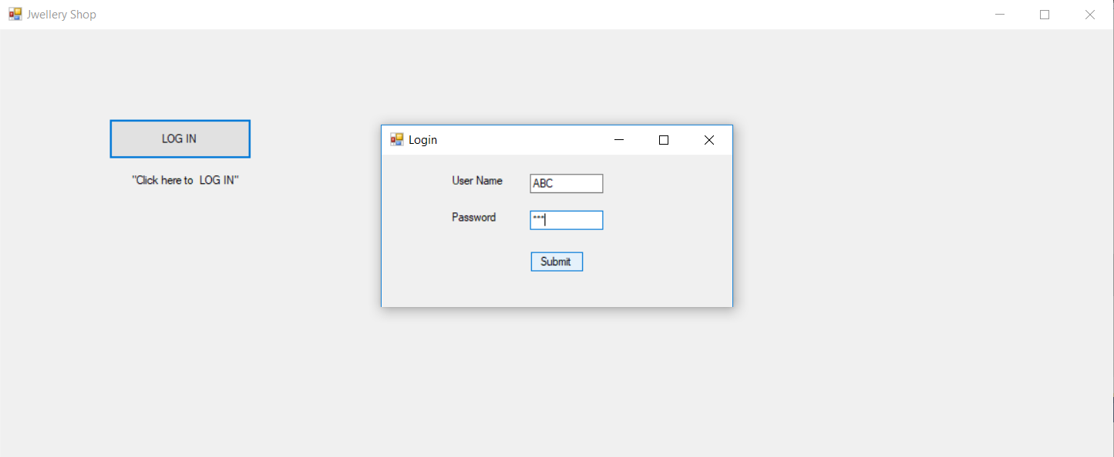

Jewellers management system

**Master Form**

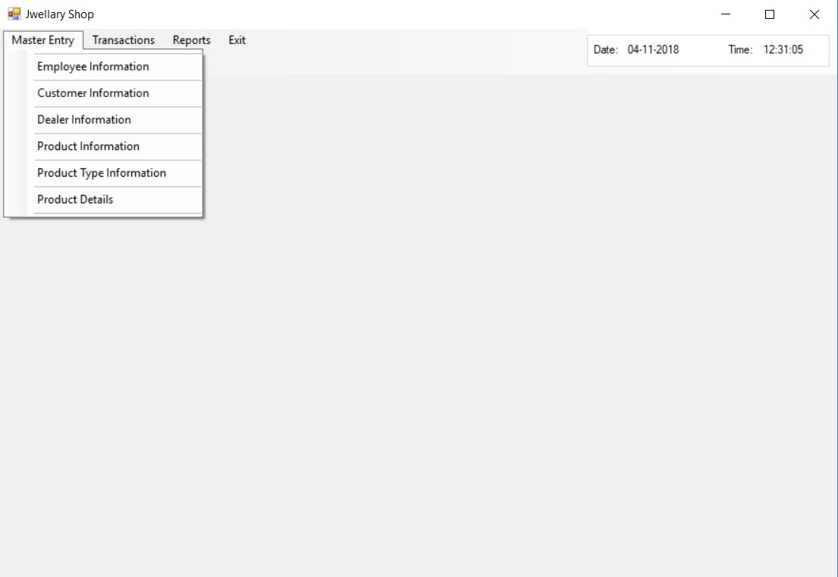

Jewellers management system

## Employee Information Form

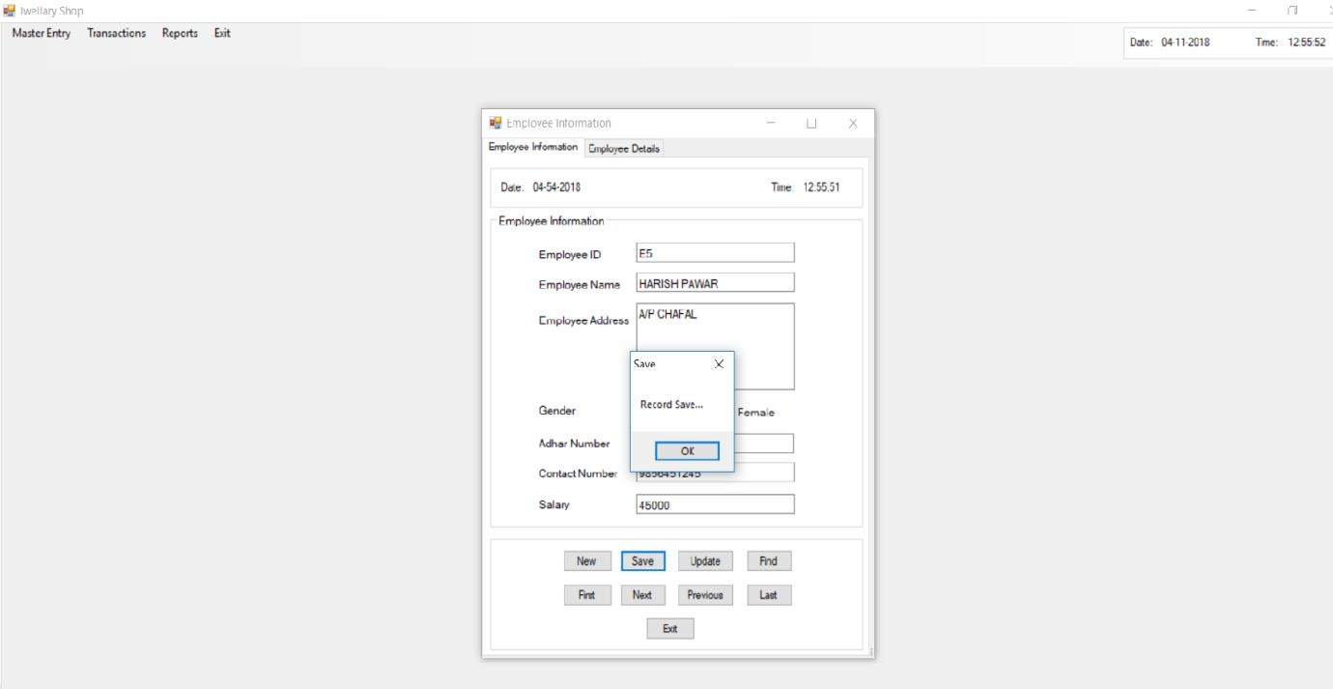

Records

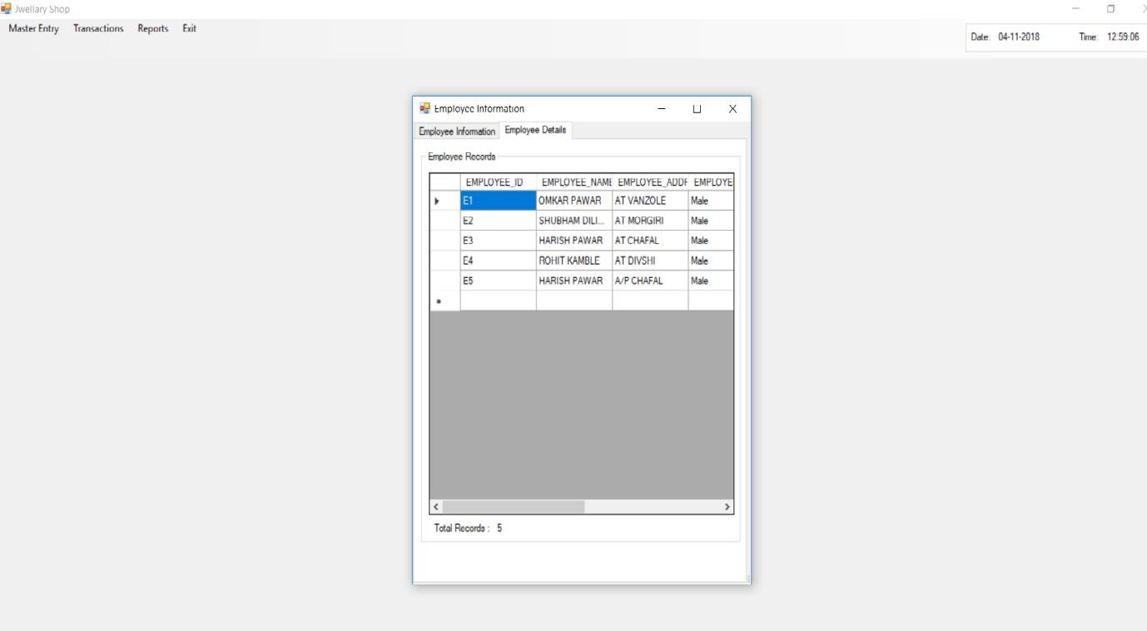

Jewellers management system

## Customer Information Form

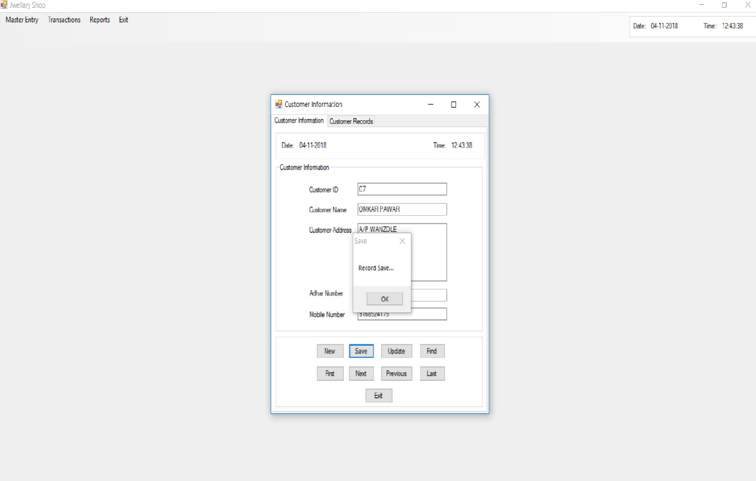

Records

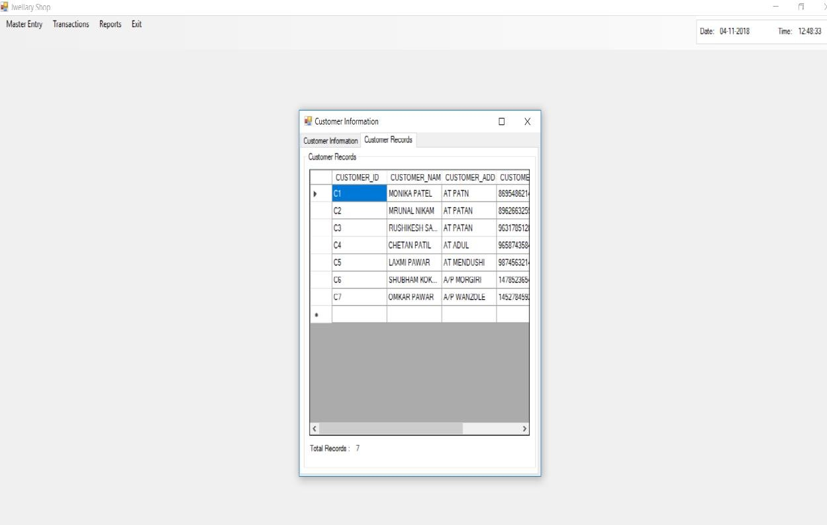

Jewellers management system

## Dealer Information Form

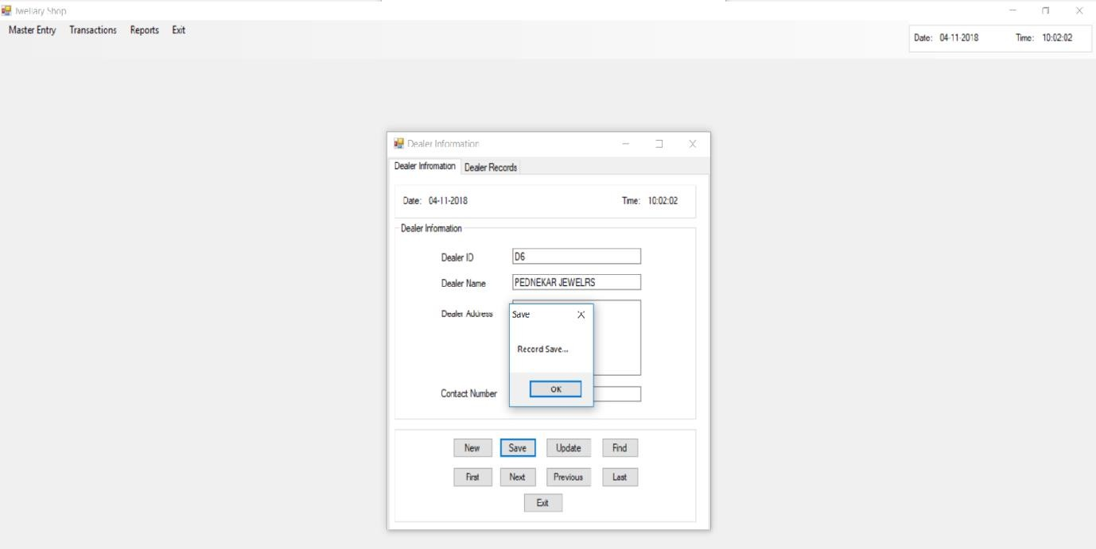

Records

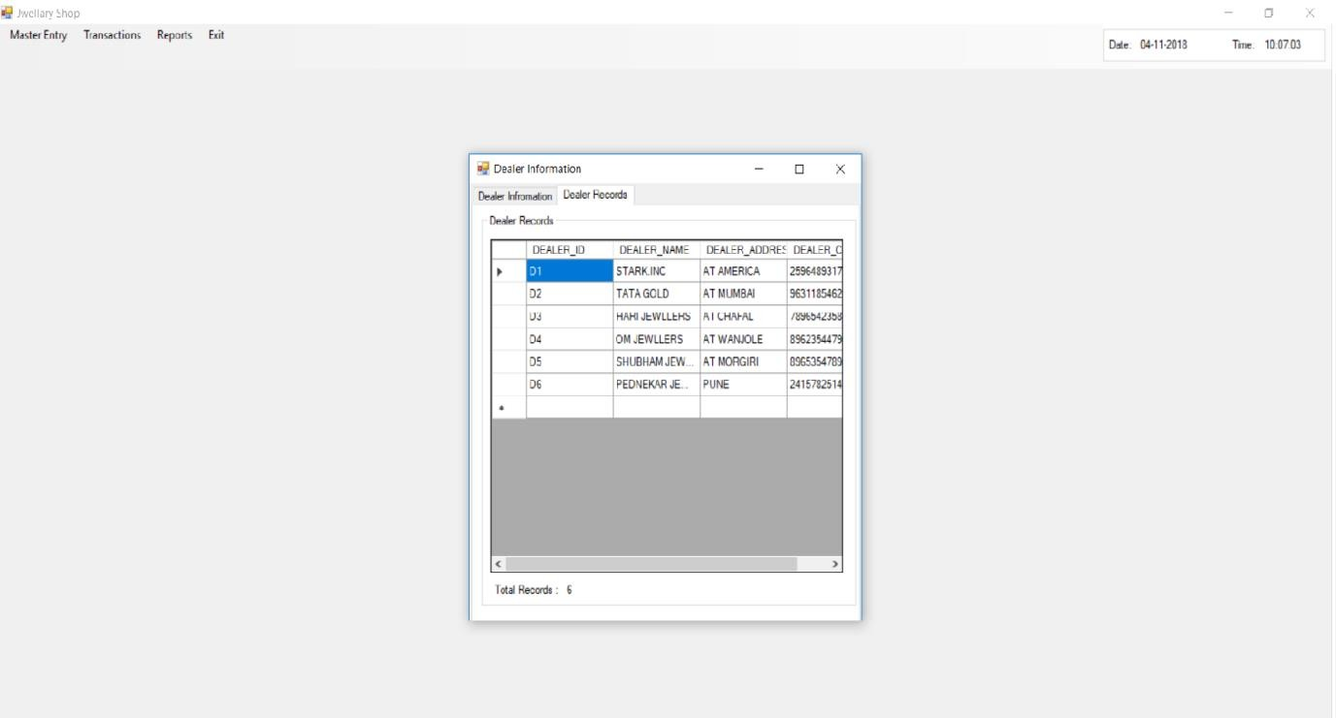

Jewellers management system

## Product Information Form

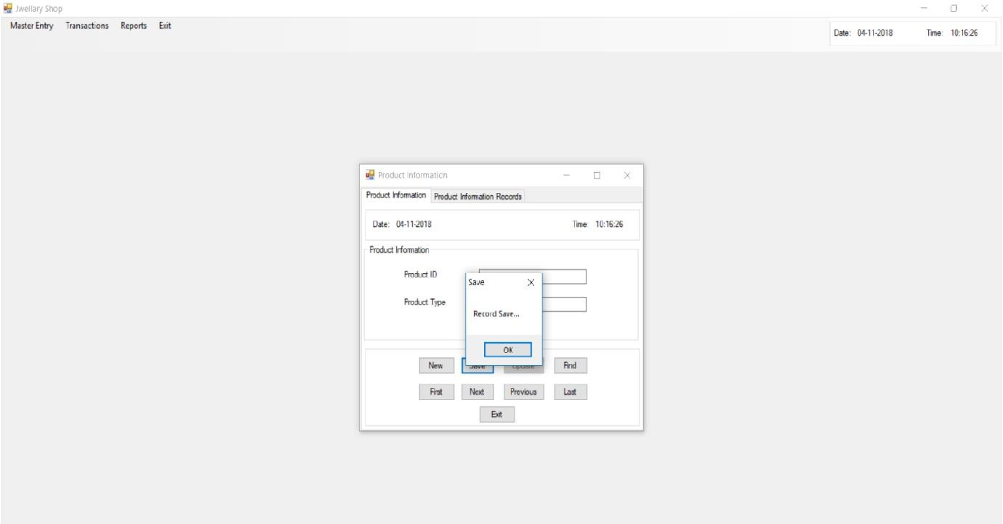

Records

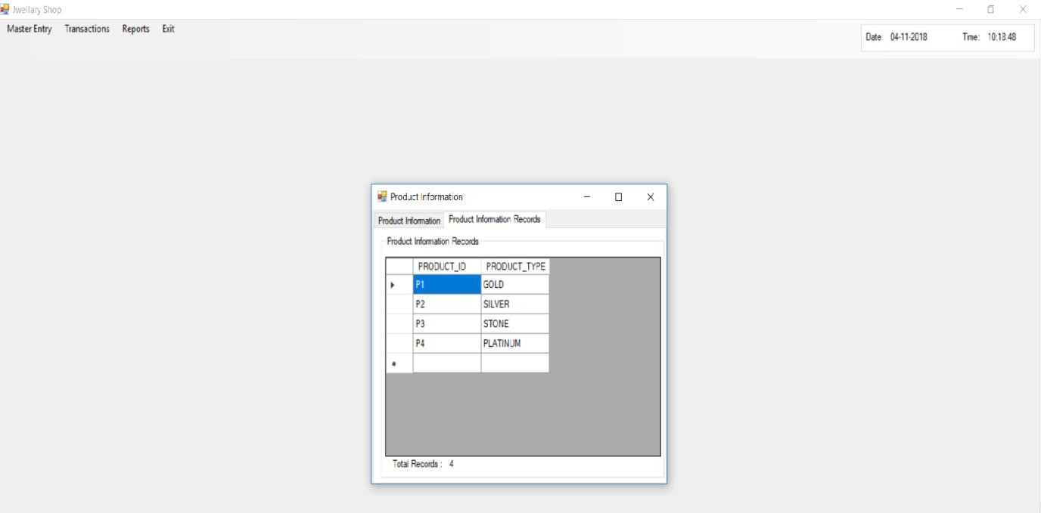

Jewellers management system

## Product Type Information Form

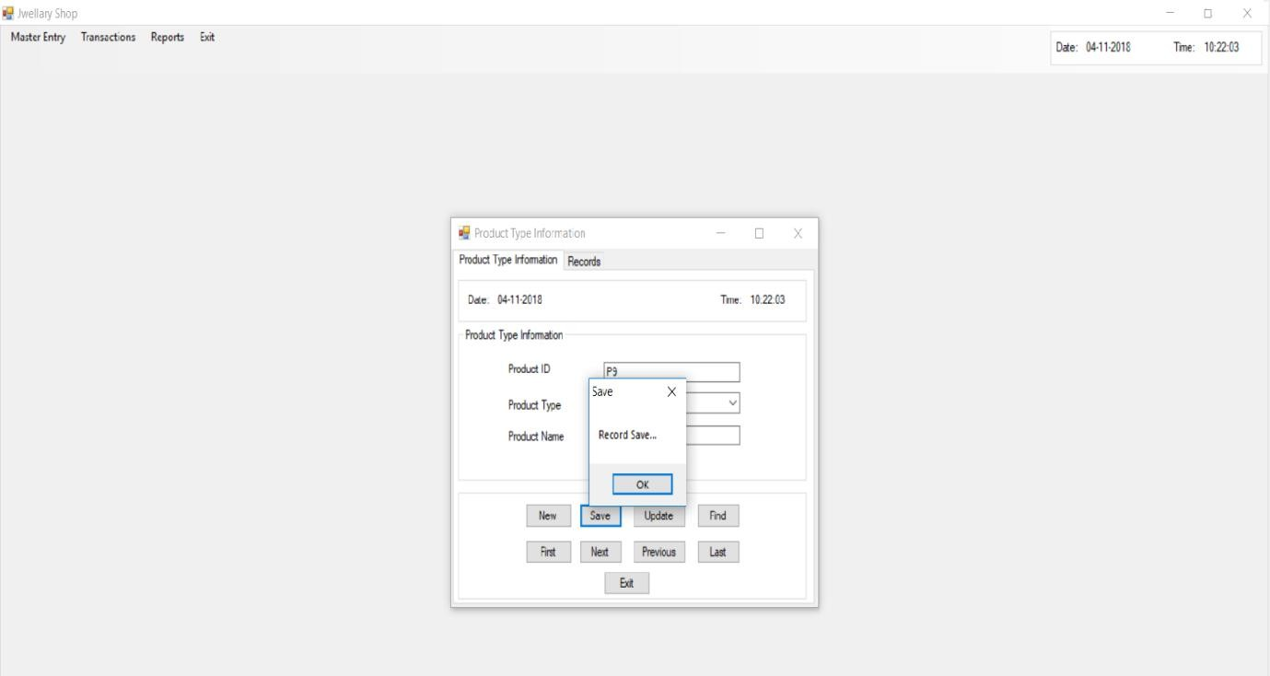

Records

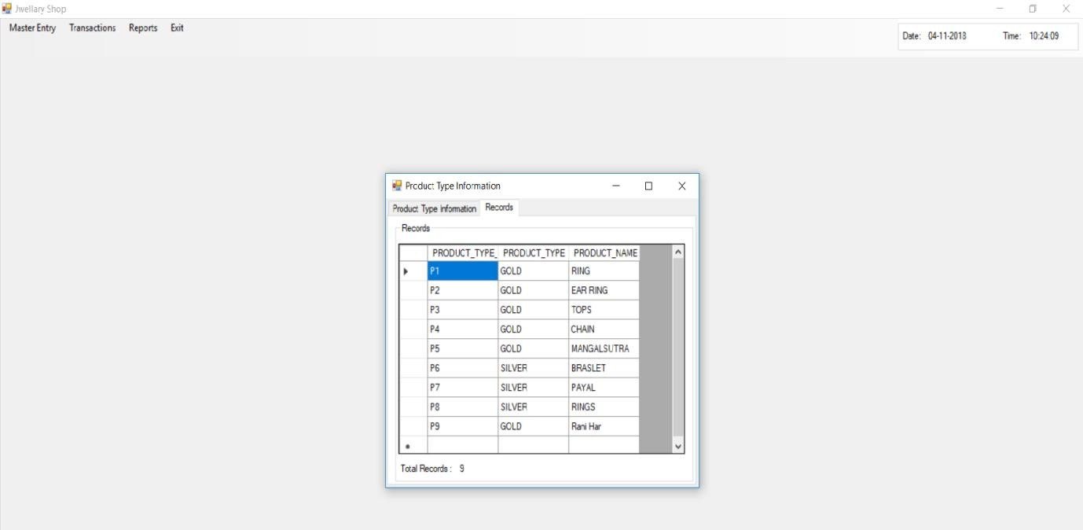

Jewellers management system

## Product Type Details Form

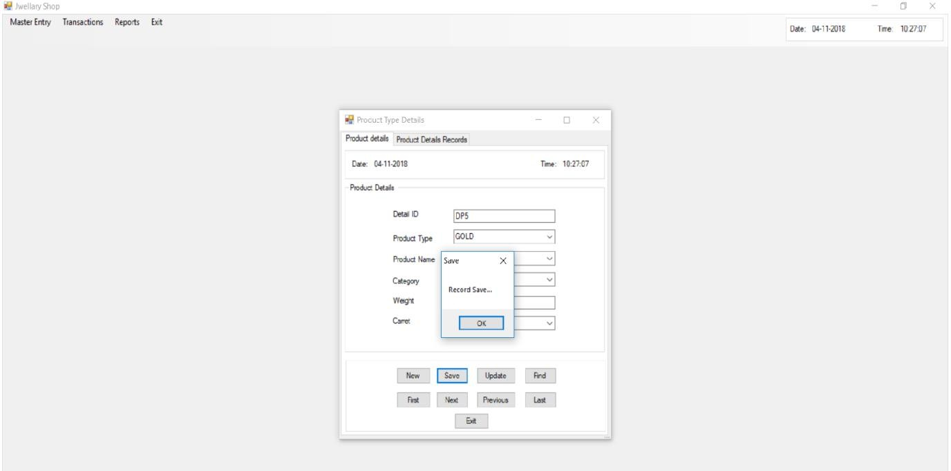

Records

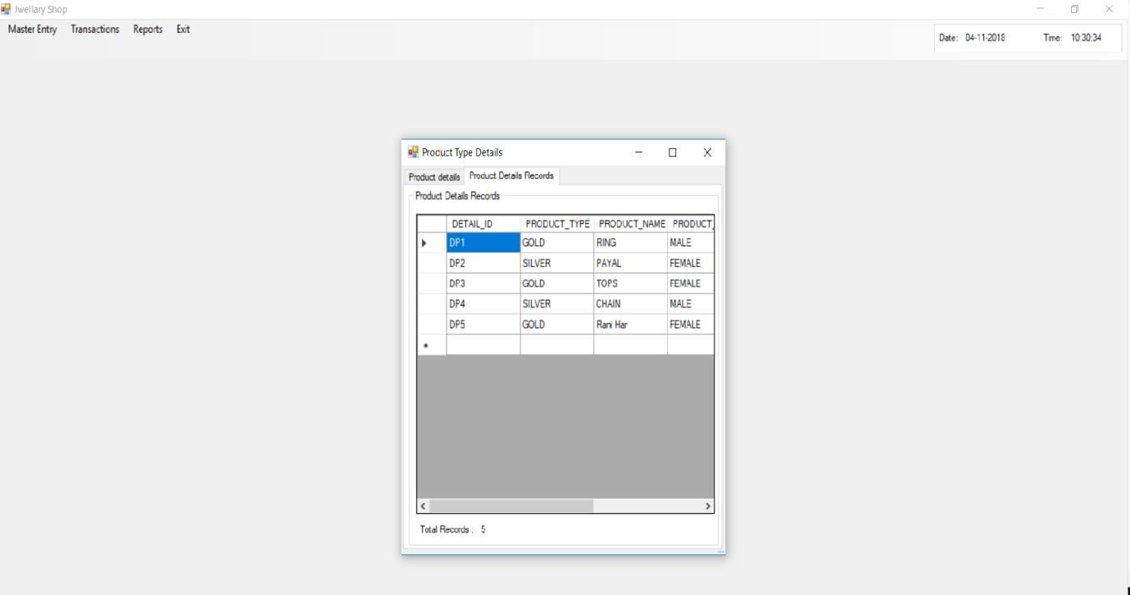

Jewellers management system

## Transaction Form

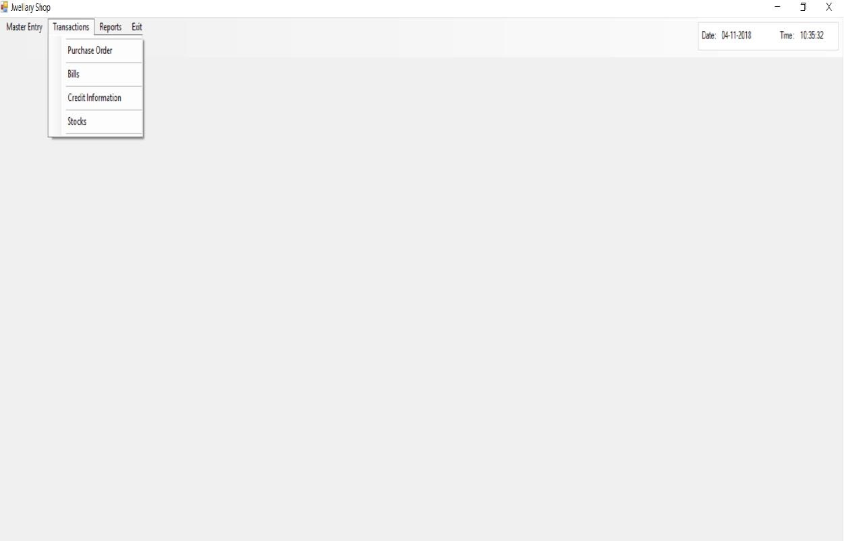

Jewellers management system

## Purchase Order Form

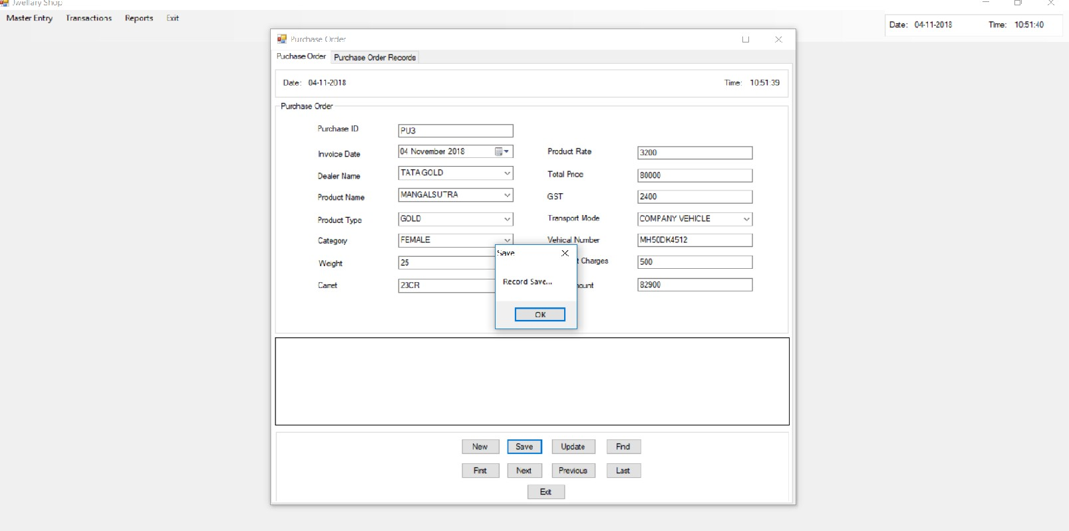

Records

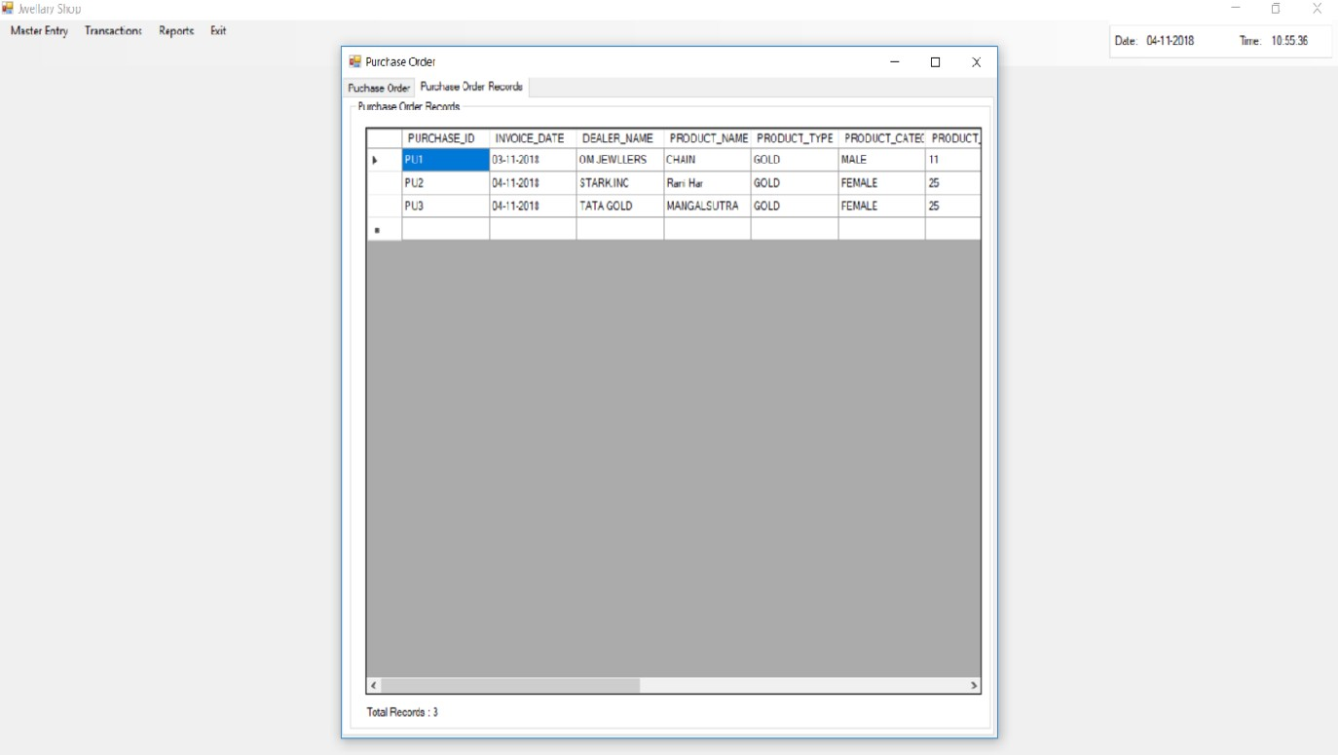

Jewellers management system

## Bill Information Form

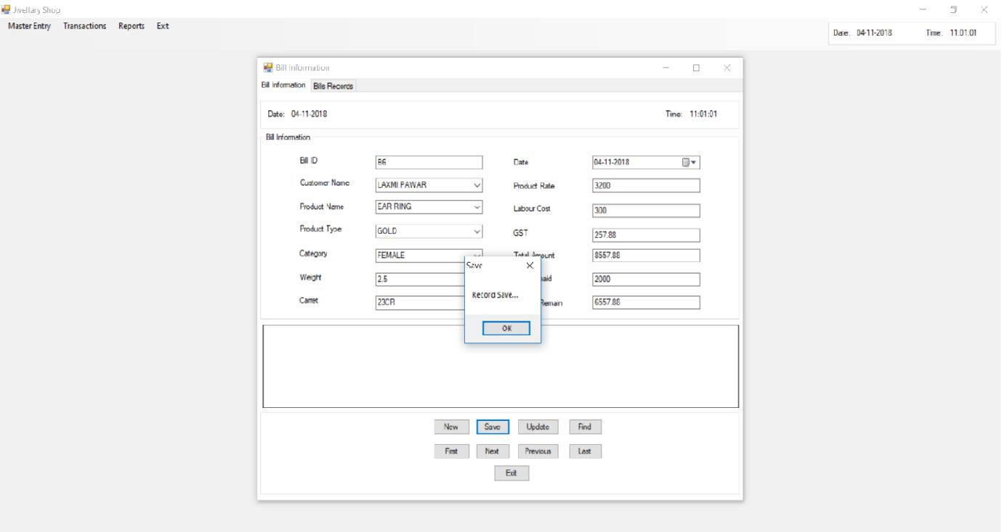

Record

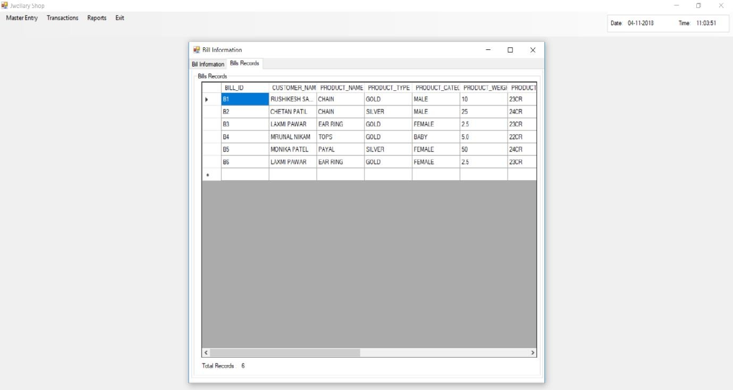

Jewellers management system

## Credit Information Form

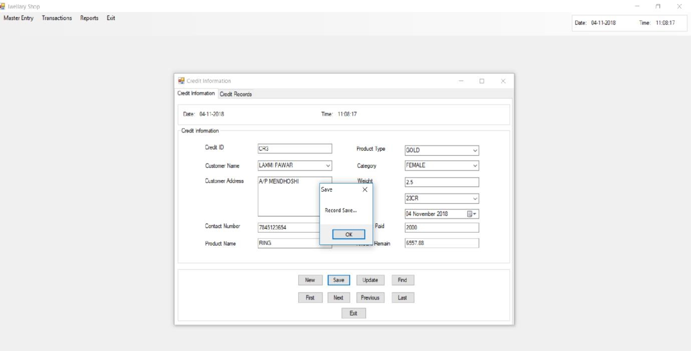

Record

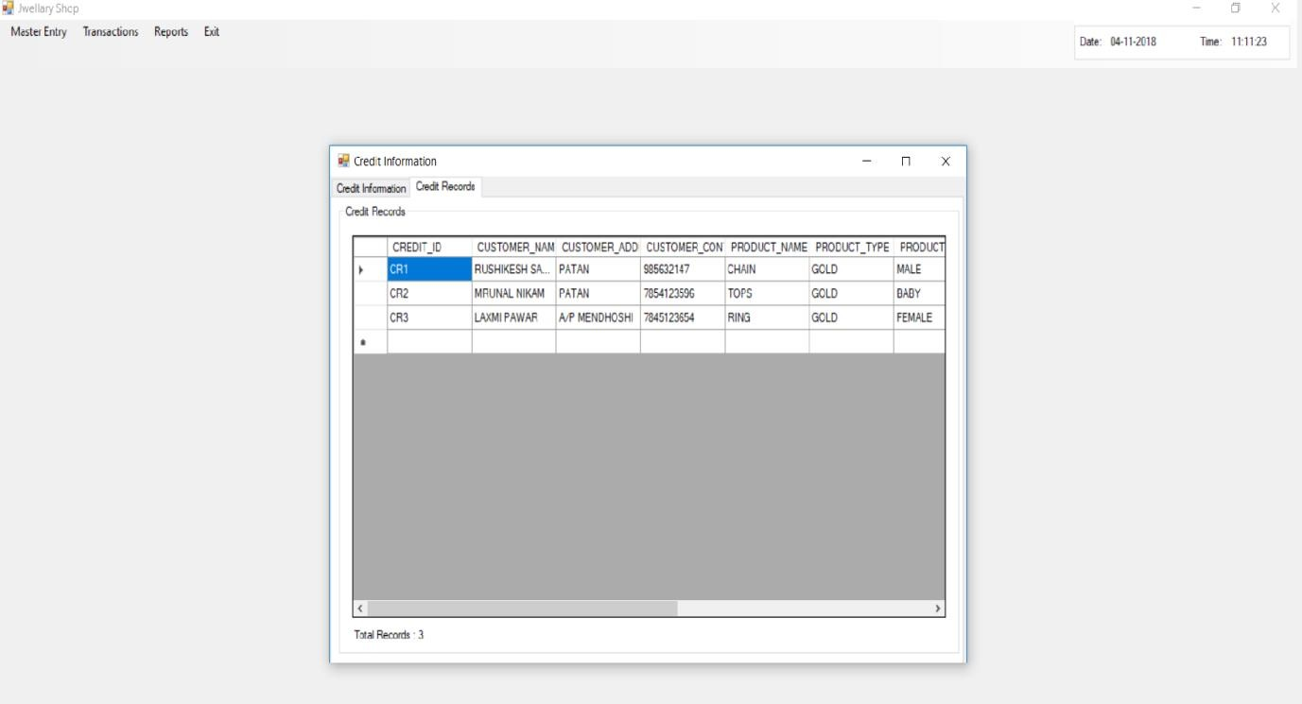

Jewellers management system

## Stock Form

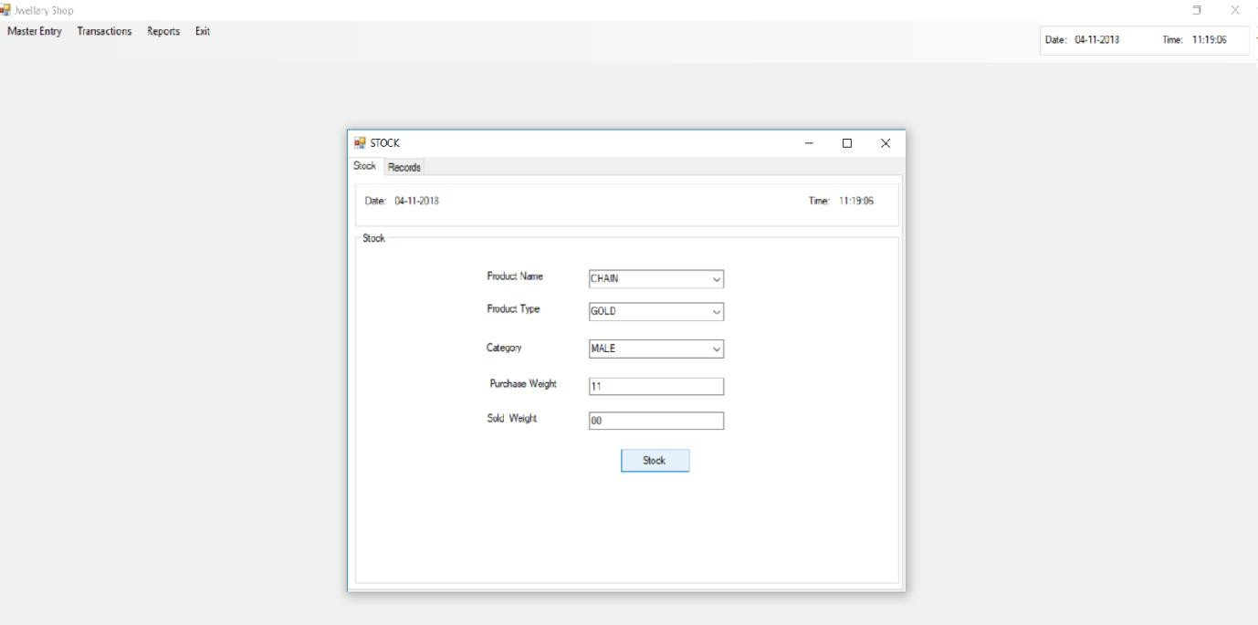

**Reports Menu**

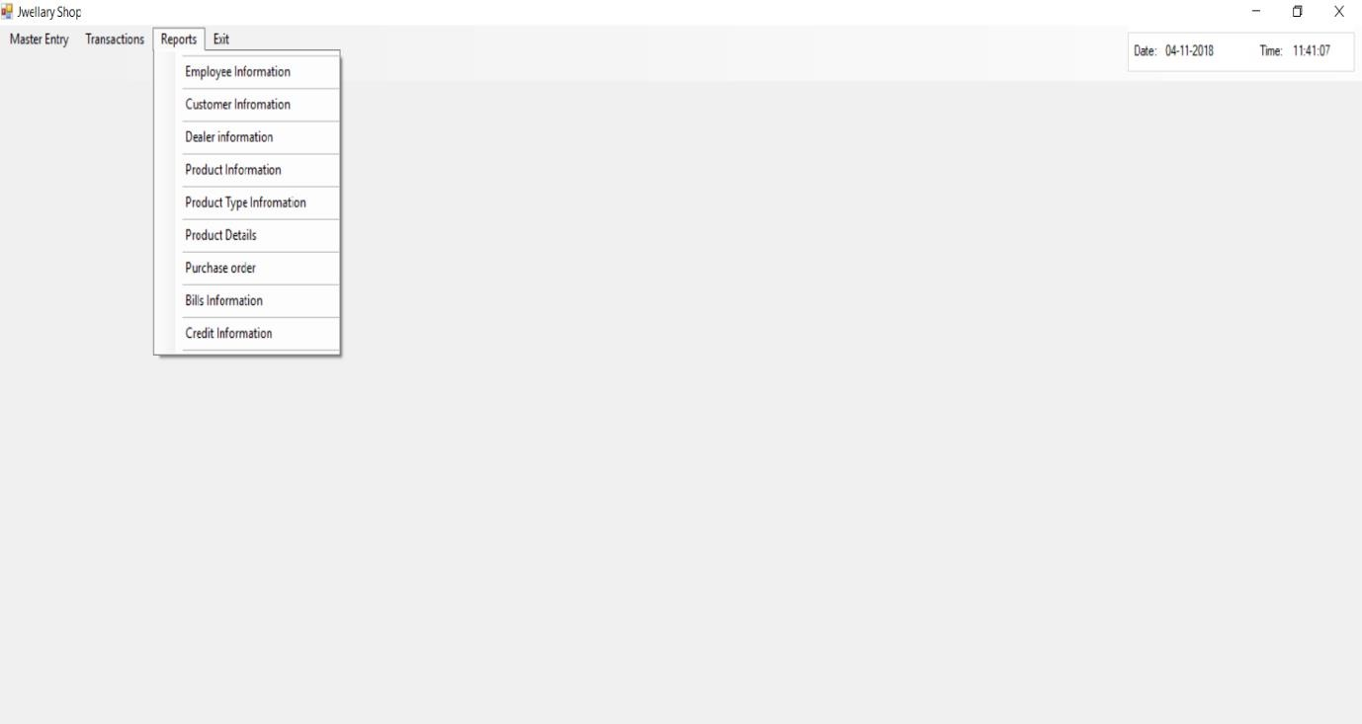

“Reports”

***#1.Employee Information Report***

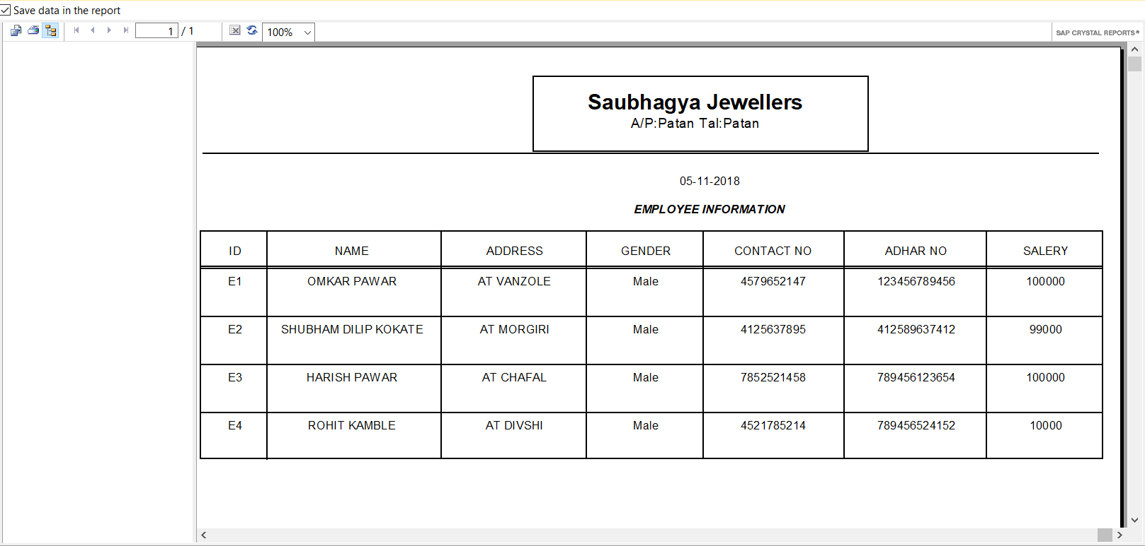

Jewellers management system

***#2.Customer Information Report***

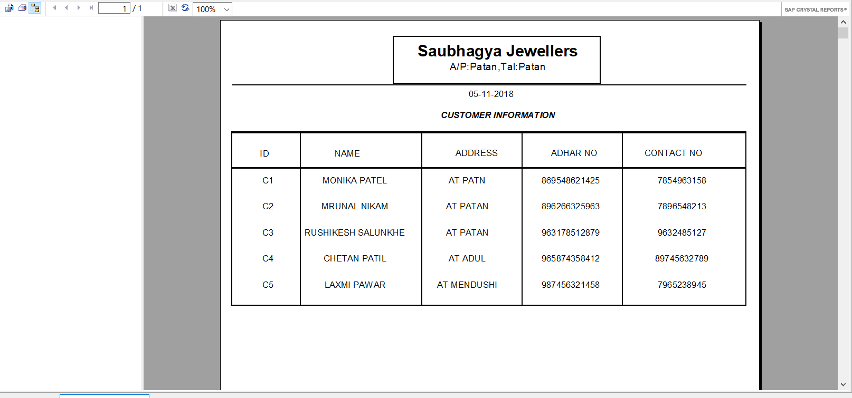

Jewellers management system

***#3.Dealer Information Report***

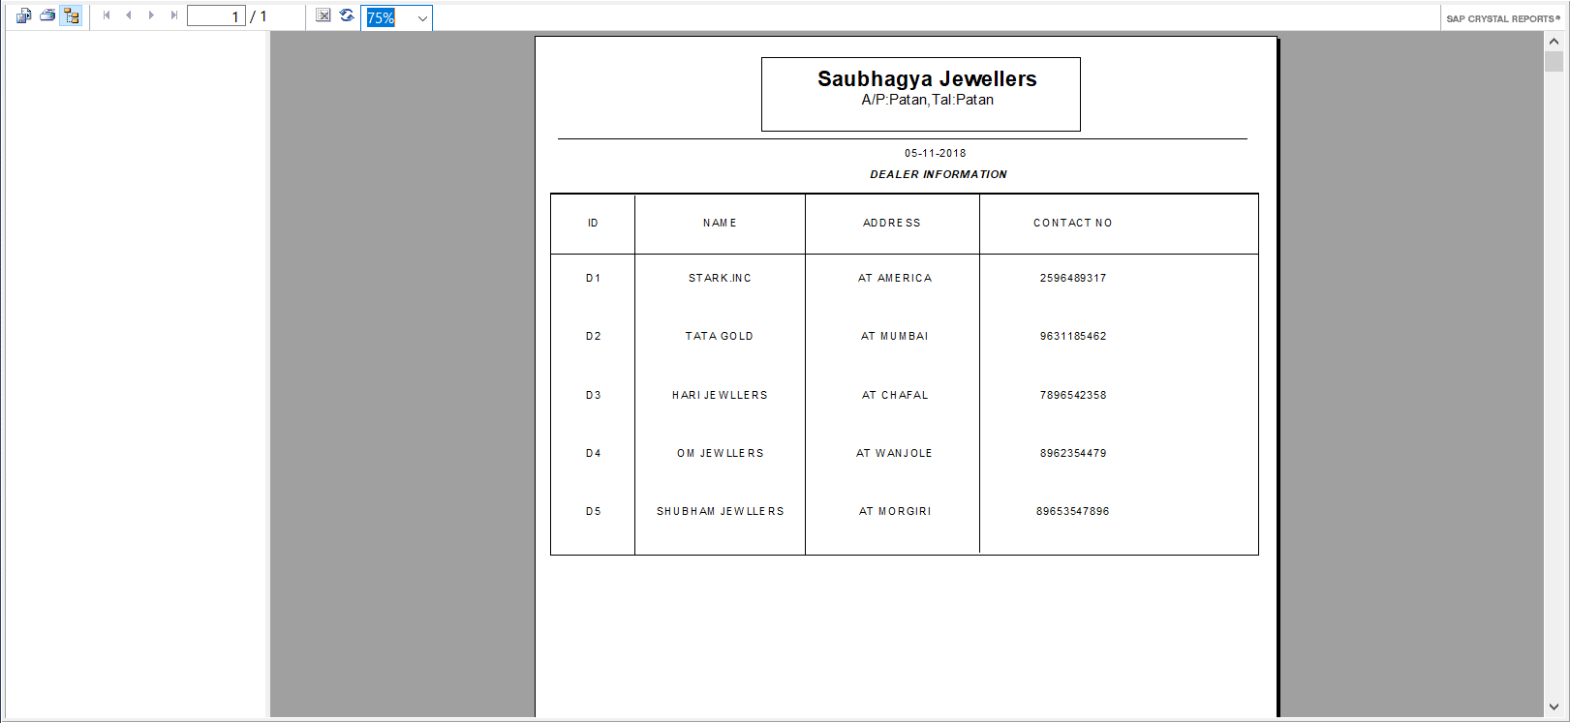

***#4.Product Information Report***

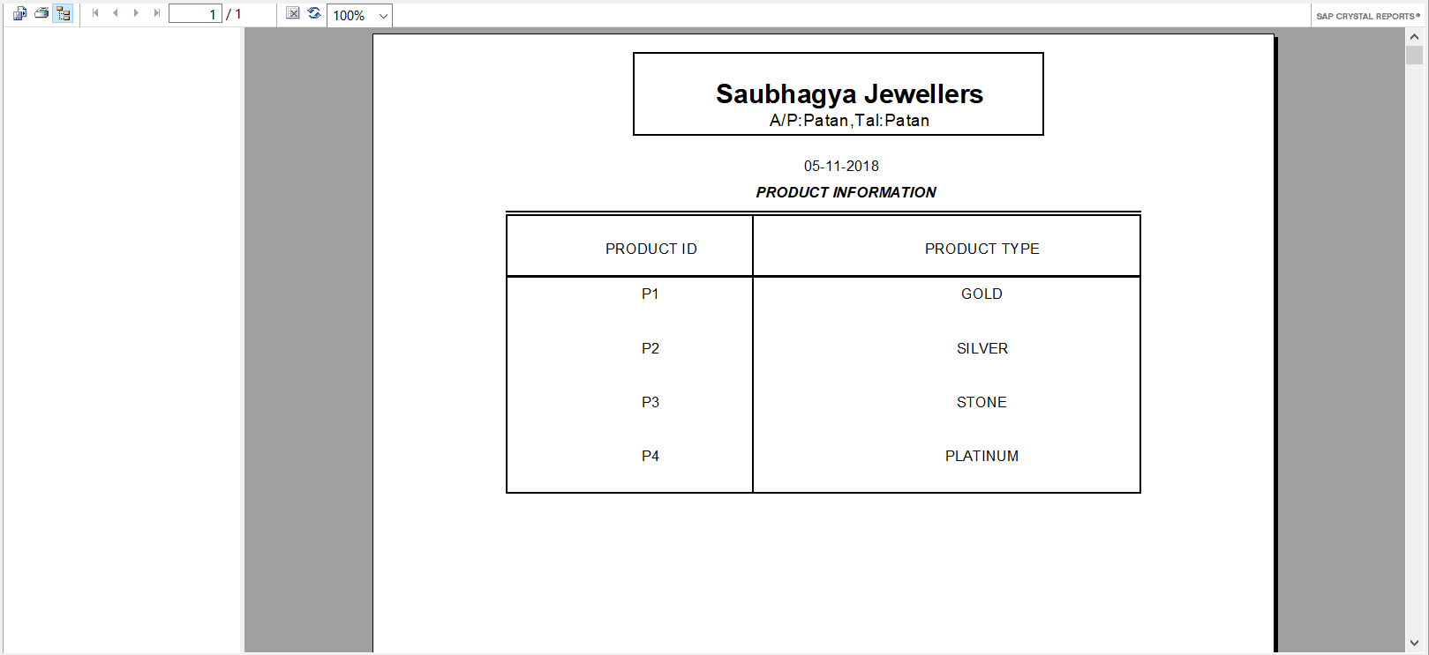

***#5.Product Type Information Report***

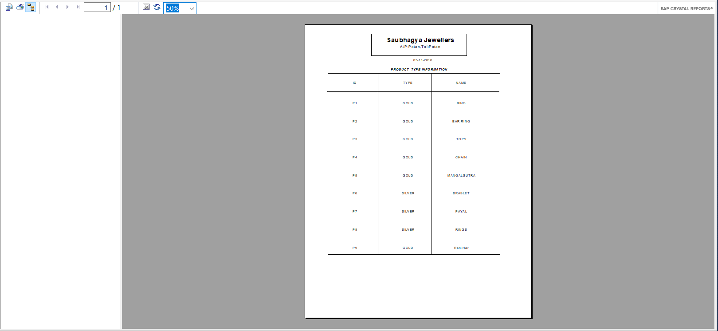

***#6.Product Type Details Report***

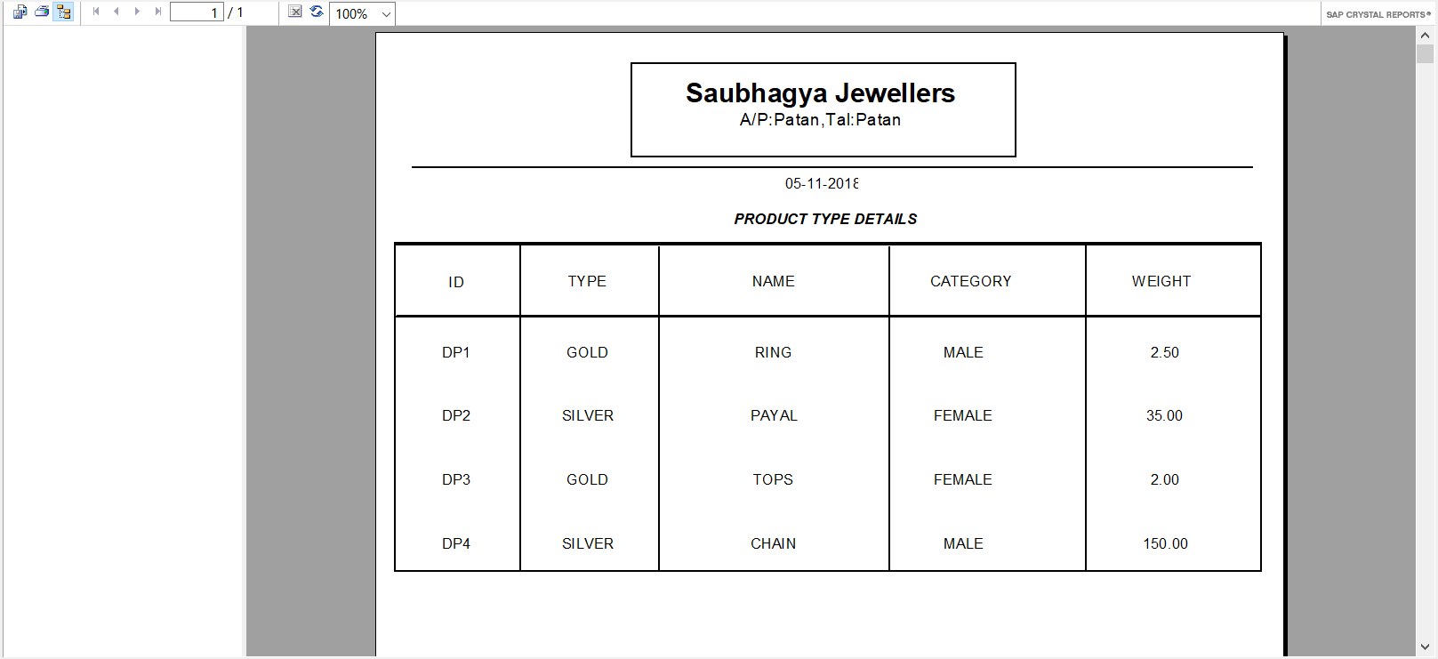

***#7.Purchase Order Report***

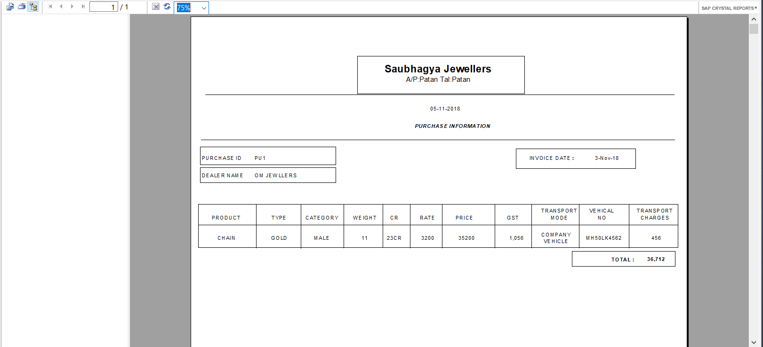

***#8.Bill Information Report***

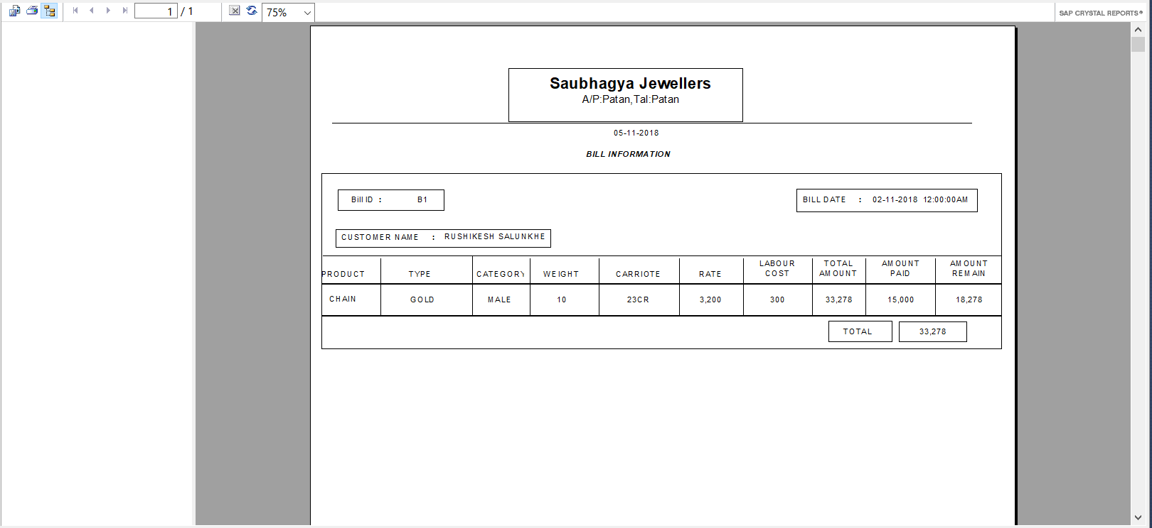

***#9.Credit Information Report***

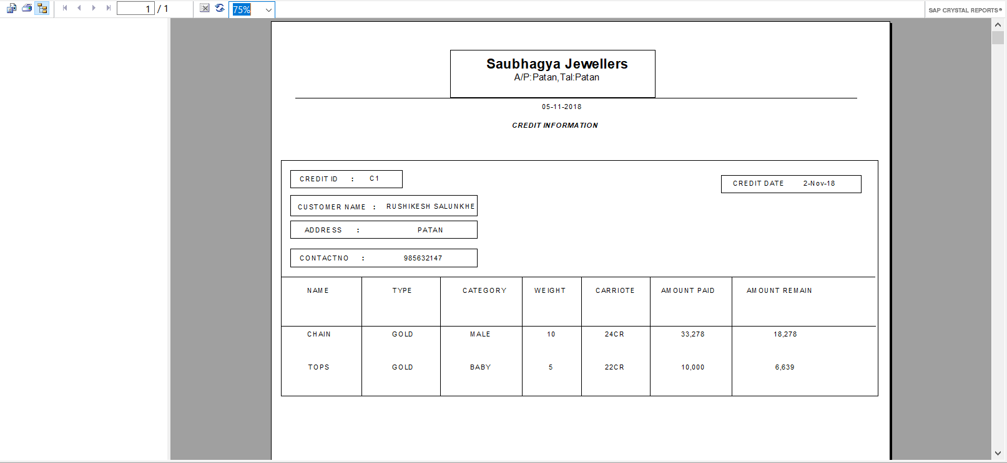

LIMITATIONS**:-**

* 1. The Application is best seen on 1024 by 768 pixels screen resolution.
  2. We not allowed online shopping.
  3. We not allow all types of Jewellery.

FUTURE MODIFICATIONS:-

The Application is developed by considering present need.

The Application has few areas where the improvement can be done.

1. To Design web Application for Jewellers Management system.
2. To provide facility for online shopping.

CONCLUSION :-

Keeping these in mind this system has been developed in a way, it should accommodate future enhancement , similarly various features have included in this system by giving due consideration of the organization. As this system is developed using modular approach it facilities easy maintenance.

We are sincerely hope that this Software System will reduce the burden of management, that it will also save a lot of their valuable time and money this exercise develops ours skills and also increase our confidence level.

Bibliography:-

1. | WEBSITE – [WWW.WAMANHARIPEDNEKARJEWELLERS.COM](http://www.wamanharipednekarjewellers.com/) [WWW.TANISHKJEWELLERS.COM.IN](http://www.tanishkjewellers.com.in/)
2. | BOOKS –

V.P 6.0 PROGRAMMING Holzer(Black Book) : By Steven

ORACLE(Complete Refrance) : By Loney Kevin

3| REFRANCE-

AMBIKA JEWELLERS MANAGEMENT SYSTEM.